Mahendra Kumar Ponnapalli

[Mahiponnapalli19@gmail.com](mailto:Mahiponnapalli19@gmail.com)

**Bank Financial Loan Analysis Project**

**Key Performance Indicators**

1 ) Total Loan Applications

SELECT COUNT(id) AS Total_Loan_Applications from [dbo].[Bank Project datase]

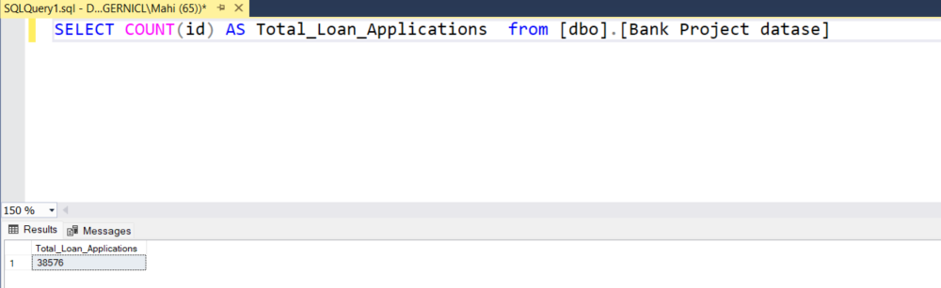

MTD Loan Applications

SELECT COUNT(id) AS MTD_Loan_Applications from [dbo].[Bank Project datase]

WHERE MONTH(issue_date)=12

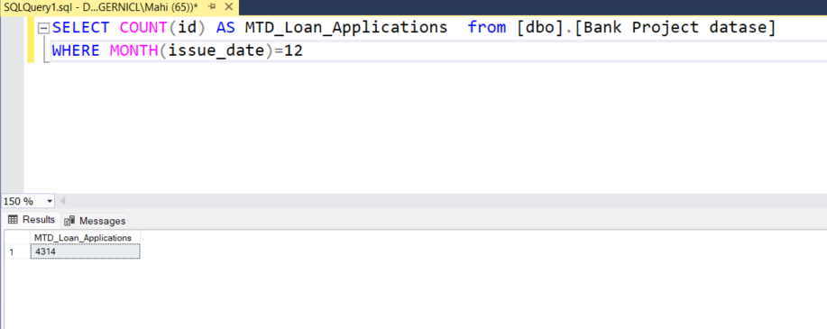

PMTD Loan Applications :

SELECT COUNT(id) AS MTD_Loan_Applications from [dbo].[Bank Project datase]

WHERE MONTH(issue_date)=11

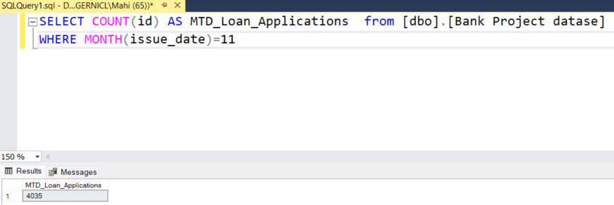

2) Total Funded amount:

SELECT SUM(loan_amount) as Total_loan_amount from [dbo].[Bank Project datase]

SELECT SUM(loan_amount) as MTD_loan_amount from [dbo].[Bank Project datase]

WHERE MONTH(issue_date)=12

SELECT SUM(loan_amount) as PMTD_loan_amount from [dbo].[Bank Project datase]

WHERE MONTH(issue_date)=11

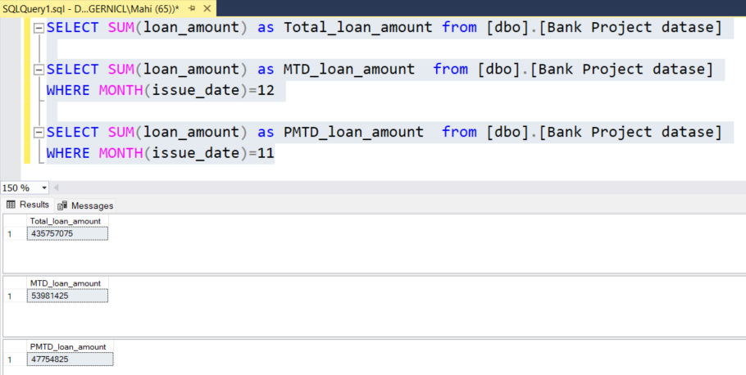

3) Total Loan Received

select sum(total_payment) as Total_Loan_Payment from [dbo].[Bank Project datase]

SELECT SUM(total_payment) as MTD_loan_Payment from [dbo].[Bank Project datase]

WHERE MONTH(issue_date)=12

SELECT SUM(total_payment) as PMTD_loan_Payment from [dbo].[Bank Project datase]

WHERE MONTH(issue_date)=11

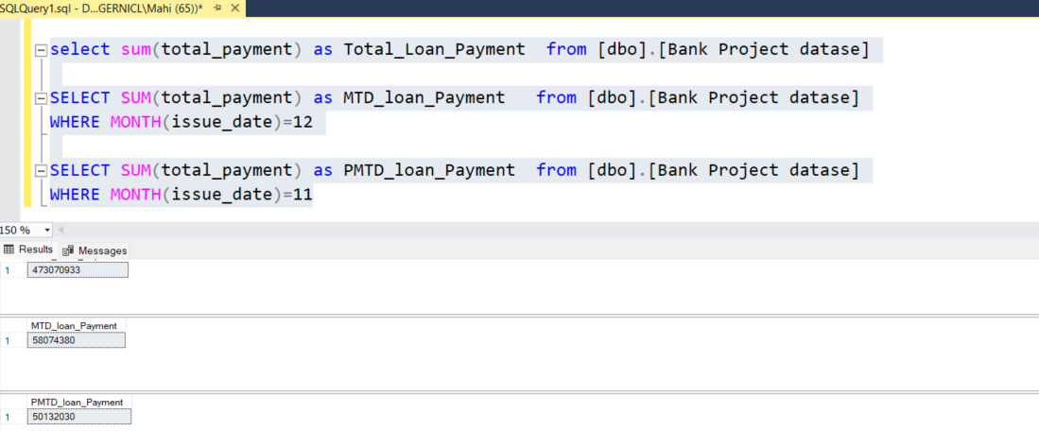

4) Average Interest rate

select round(AVG(int_rate),4)*100 as Average_int_rate from [dbo].[Bank Project datase]

SELECT round(AVG(int_rate),4)*100 as MTD_Average_int_rate from [dbo].[Bank Project datase]

WHERE MONTH(issue_date)=12

SELECT round(AVG(int_rate),4)*100 as PMTD_Average_int_rate from [dbo].[Bank Project datase]

WHERE MONTH(issue_date)=11

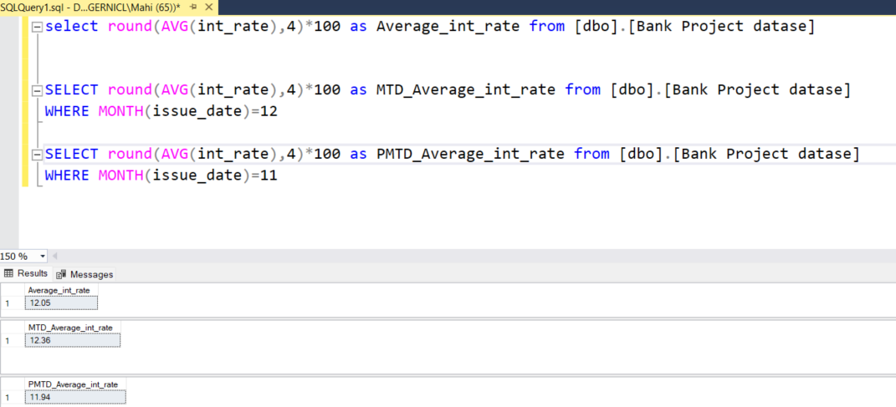

5) Average DTI

select round(AVG(dti),4)*100 as Average_dti from [dbo].[Bank Project datase]

SELECT round(AVG(dti),4)*100 as MTD_Average_dti from [dbo].[Bank Project datase]

WHERE MONTH(issue_date)=12

SELECT round(AVG(dti),4)*100 as PMTD_Average_dti from [dbo].[Bank Project datase]

WHERE MONTH(issue_date)=11

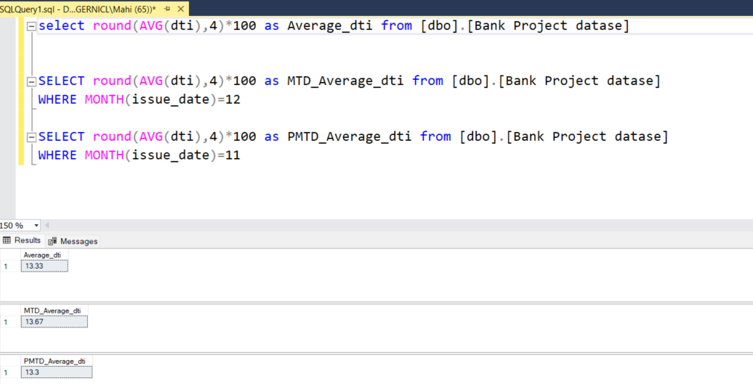

**Good Loan Issued :**

Good loan Percentage :

SELECT

(COUNT(CASE WHEN loan_status = 'Fully Paid' OR loan_status = 'Current' THEN id End)*100)

/

COUNT(id) AS Good_loan_percentage from [dbo].[Bank Project datase]

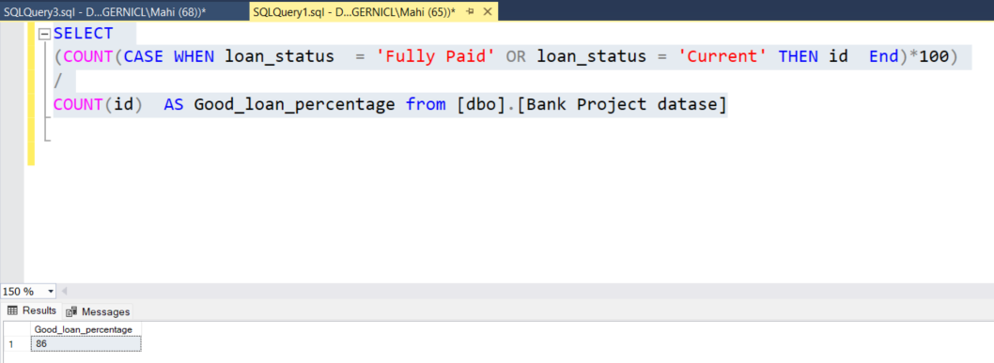

Good Loan Application

SELECT COUNT(id) AS Good_loan_Percentage FROM [dbo].[Bank Project datase]

WHERE loan_status = 'Fully Paid' OR loan_status = 'Current'

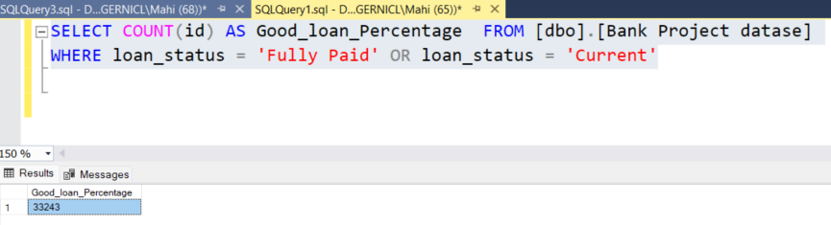

Good loan Funded Amount

SELECT SUM(loan_amount) AS Good_Loan_Funded_amount FROM [dbo].[Bank Project datase]

WHERE loan_status = 'Fully Paid' OR loan_status = 'Current'

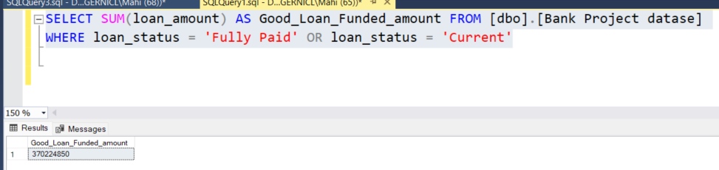

Good Loan Amount Received :

SELECT SUM(total_payment) AS Good_Loan_amount_received FROM [dbo].[Bank Project datase]

WHERE loan_status = 'Fully Paid' OR loan_status = 'Current'

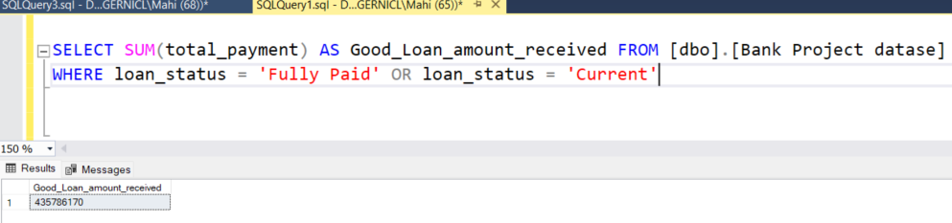

**Bad Loan Issued :**

Bad Loan Percentage:

SELECT

(COUNT(CASE WHEN loan_status = 'Charged Off' THEN id END) * 100.0) /

COUNT(id) AS Bad_Loan_Percentage

FROM [dbo].[Bank Project datase]

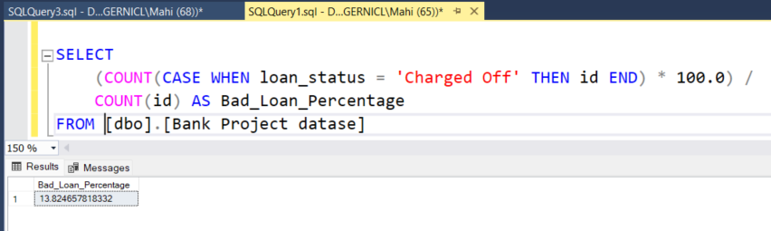

Bad loan Application

SELECT COUNT(id) AS Bad_Loan_Applications FROM [dbo].[Bank Project datase]

WHERE loan_status = 'Charged Off'

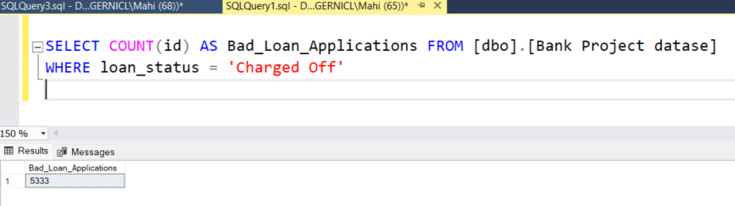

**Bad Loan Funded Amount**

SELECT SUM(loan_amount) AS Bad_Loan_Funded_amount FROM [dbo].[Bank Project datase]

WHERE loan_status = 'Charged Off'

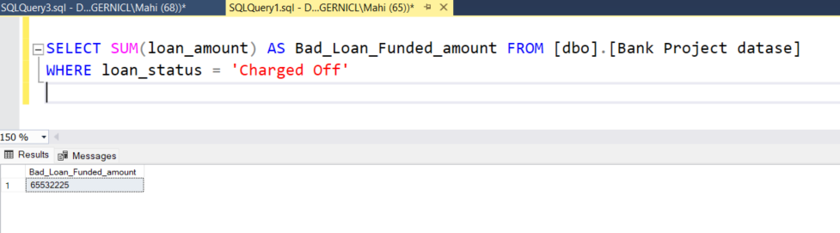

**Bad Loan Amount Received**

SELECT SUM(total_payment) AS Bad_Loan_amount_received FROM [dbo].[Bank Project datase]

WHERE loan_status = 'Charged Off'

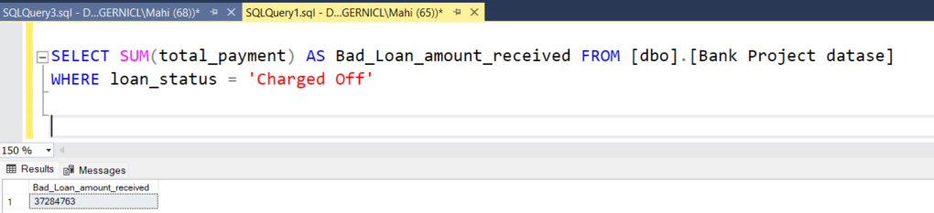

**Loan Status**

SELECT

loan_status,

COUNT(id) AS LoanCount,

SUM(total_payment) AS Total_Amount_Received,

SUM(loan_amount) AS Total_Funded_Amount,

AVG(int_rate * 100) AS Interest_Rate,

AVG(dti * 100) AS DTI

FROM

[dbo].[Bank Project datase]

GROUP BY

loan_status

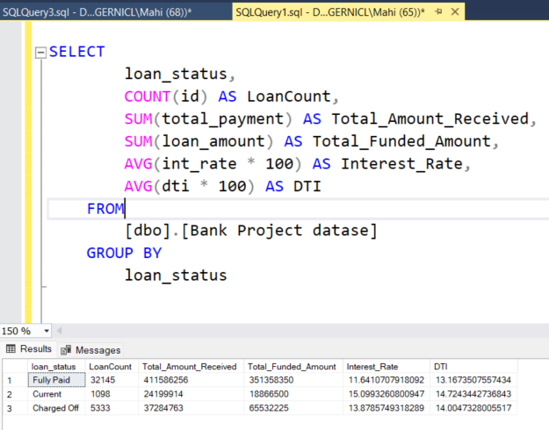

SELECT

loan_status,

SUM(total_payment) AS MTD_Total_Amount_Received,

SUM(loan_amount) AS MTD_Total_Funded_Amount

FROM [dbo].[Bank Project datase]

WHERE MONTH(issue_date) = 12

GROUP BY loan_status

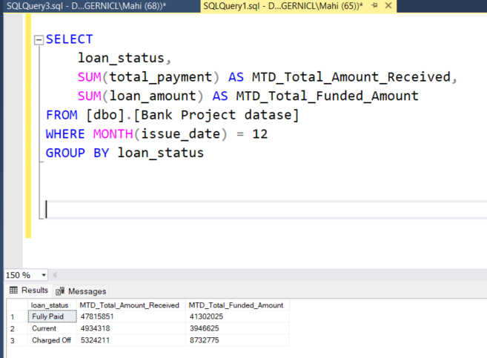

**DashBoard 2 :**

**Bank Loan Report Overview**

**Monthly:**

SELECT

MONTH(issue_date) AS Month_Munber,

DATENAME(MONTH, issue_date) AS Month_name,

COUNT(id) AS Total_Loan_Applications,

SUM(loan_amount) AS Total_Funded_Amount,

SUM(total_payment) AS Total_Amount_Received

FROM [dbo].[Bank Project datase]

GROUP BY MONTH(issue_date), DATENAME(MONTH, issue_date)

ORDER BY MONTH(issue_date)

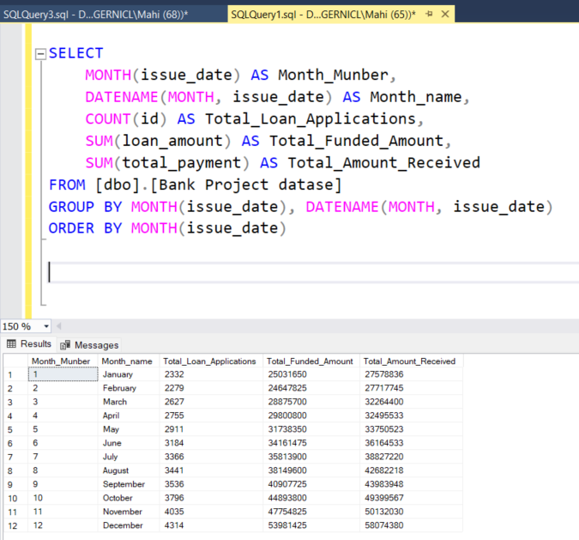

**State :**

SELECT

address_state AS State,

COUNT(id) AS Total_Loan_Applications,

SUM(loan_amount) AS Total_Funded_Amount,

SUM(total_payment) AS Total_Amount_Received

FROM [dbo].[Bank Project datase]

GROUP BY address_state

ORDER BY address_state

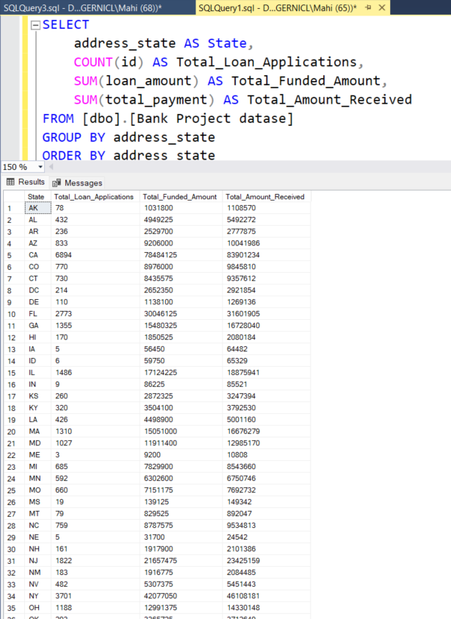

**C) Term wise**

SELECT

term AS Term,

COUNT(id) AS Total_Loan_Applications,

SUM(loan_amount) AS Total_Funded_Amount,

SUM(total_payment) AS Total_Amount_Received

FROM [dbo].[Bank Project datase]

GROUP BY term

ORDER BY term

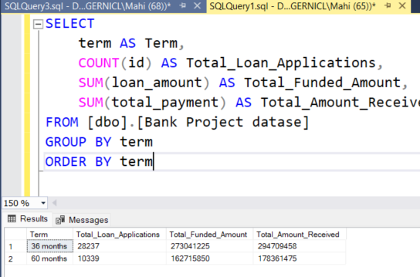

**D) Employee Length**

SELECT

emp_length AS Employee_Length,

COUNT(id) AS Total_Loan_Applications,

SUM(loan_amount) AS Total_Funded_Amount,

SUM(total_payment) AS Total_Amount_Received

FROM [dbo].[Bank Project datase]

GROUP BY emp_length

ORDER BY emp_length

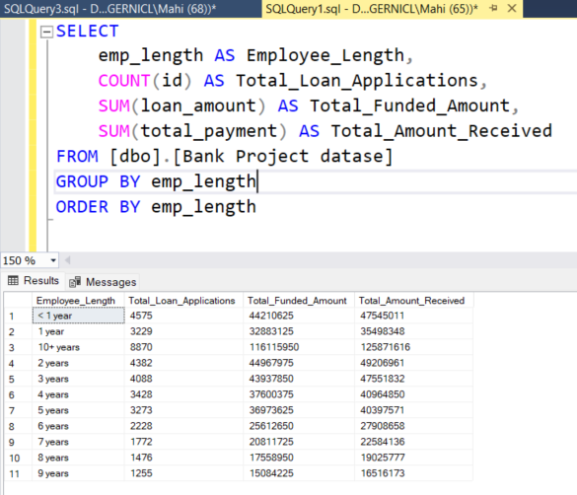

**Purpose:**

SELECT

purpose AS PURPOSE,

COUNT(id) AS Total_Loan_Applications,

SUM(loan_amount) AS Total_Funded_Amount,

SUM(total_payment) AS Total_Amount_Received

FROM [dbo].[Bank Project datase]

GROUP BY purpose

ORDER BY purpose

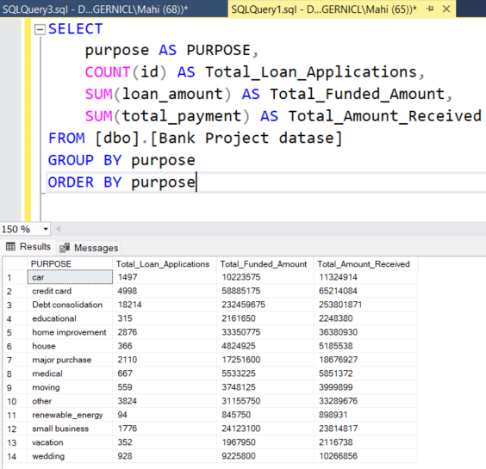

**Home Ownership:**

SELECT

home_ownership AS Home_Ownership,

COUNT(id) AS Total_Loan_Applications,

SUM(loan_amount) AS Total_Funded_Amount,

SUM(total_payment) AS Total_Amount_Received

FROM [dbo].[Bank Project datase]

GROUP BY home_ownership

ORDER BY home_ownership

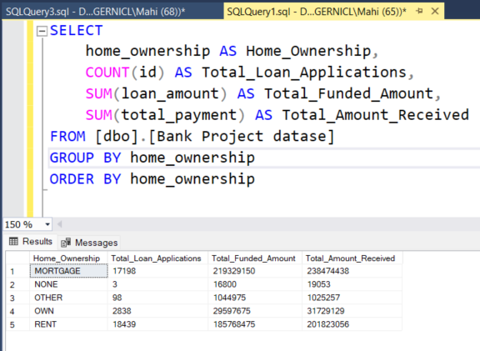

**This is the Result when we do filtering according to Grade**

SELECT

purpose AS PURPOSE,

COUNT(id) AS Total_Loan_Applications,

SUM(loan_amount) AS Total_Funded_Amount,

SUM(total_payment) AS Total_Amount_Received

FROM [dbo].[Bank Project datase]

WHERE grade = 'A'

GROUP BY purpose

ORDER BY purpose

